**HXN Operation Manual**

**V0.4**

# Contents

1 Contents 1

2 Computers 3

2.1 Login credential 3

2.2 Reboot computer 3

3 Beamline Control 3

3.1 Start css 3

3.2 Monitor beamline status 4

3.3 Beam loss 5

4 Scan Engine 5

4.1 How to start 5

4.2 Commands in ophyd/bluesky 5

4.2.1 How to move/scan Motors? 6

4.2.2 Step scans 6

4.2.3 Fly scans 7

4.2.4 Plot, fit, print and export scalar data 7

4.2.5 MLL-module specific commands 8

4.2.6 ZP-module specific commands 9

4.2.7 Diffraction stages 10

4.2.8 Miscellaneous 11

4.3 Add comments to scans 12

4.3.1 Case 1: add comments to one scan 12

4.4 User macros 12

4.5 Troubleshooting 12

5 Create a pdf file for experiment log 13

6 Data Analysis 15

6.1 Fetch data via dataBroker 15

6.2 Create your own workspace directory 15

6.3 pyXRF 15

6.3.2 Run pyXRF 16

6.3.3 Batch processing 16

6.4 PyDPC 17

5.5 Matlab 22

5.6 Ptychography 22

7 Diving board 23

**8** Sample Exchange 25

8.1 Venting the chamber 25

8.2 Evacuating the chamber 25

8.3 Auto He back Fill 26

# Computers

## Login credential

* Computers (workstations) at HXN are named as xf03idc-ws1, ws2, …, ws5.
* Workstation 1 is for experiment control
* Workstation 2, 4 and the windows machine is for data analysis.
* Workstation 3 is designated for status monitoring. Do not run any analysis software on it.
* For computation intense data analysis, one can use xf03idc-srv2 and xf03idc-srv5, which are equipped with powerful GPU cards.

Command line: **ssh –YC xf03id@xf03id-*srv5***

|  |  |  |
| --- | --- | --- |
|  | user | password |
| xf03idc-ws1, ws2, …, ws5 | xf03id | Hxn_1603 |
| xf03id-srv2 | Xf03id | Hxn_1603 |
| SEM computer | .\hxnuser | Hxn_1603 |
| HXN google account | hxn.nsls2@gmail.com | nanoprobe |

## Reboot computer

Workstation 1 or 2 can be rebooted if it becomes extremely slow or frozen. At terminal, type “reboot” or “systemctl reboot”. However, you need ‘sudo’ privileges to do so!

# Beamline Control

## Start css

The graphic control of the beamline is done through css. To start it, at any terminal type “run-css”. Usually it will bring up the previously-configured panel. If not, click “03 ID(HXN) Main” from the menu bar (see below figures). For beamline controls, click “Overviews” and then select “Upstream overview”. For microscope control, click “Zone Plate Module” or “MLL Module”, depending which module is in use. Control windows for all the components can be launched from the main panel. Currently there are no access controls so only launch ones that you are allowed to play with.

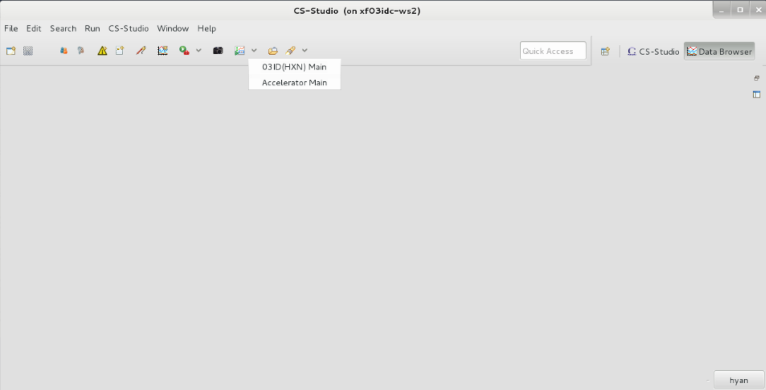

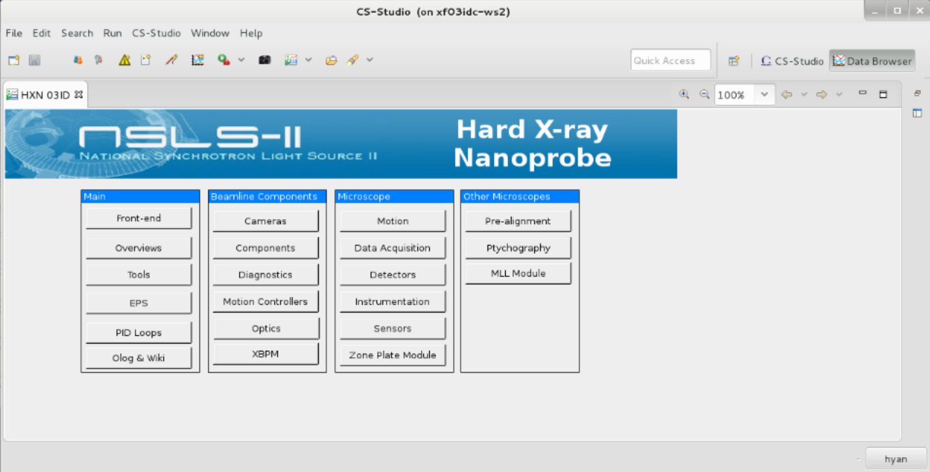

## Monitor beamline status

There are two TVs hanging on the wall which displays the ring status (left) and beamline status (right). For the beamline, everything should be green except Win-1 and Win2 (see below figure).

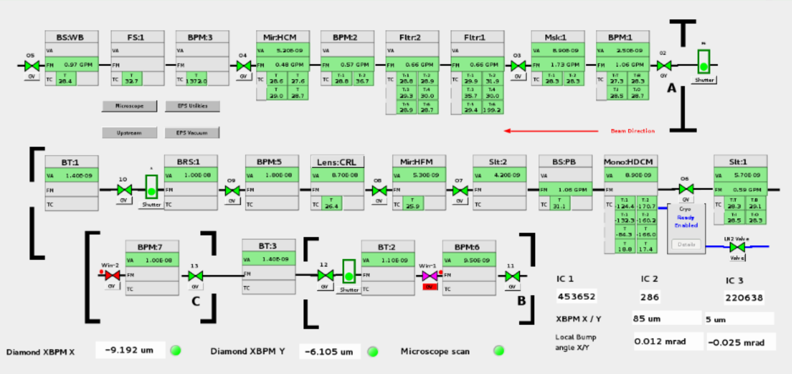

## Beam loss

In the event of beam loss (both ic1 and ic3 are zero), first check whether the beam is dumped or the shutter is disable (check TV on the left). Second, check if the front-end shutter is closed (top-right shutter) and if anything in the above figure turn into red. If none of them happens, check Diamond XBPM X and Y positions (bottom-left). They are supposed to be near zero. If a very large (several hundred) number is seen, then it is most likely the feedback that drives the piezo to the limit and steer away the beam. If it is still not the case, check undulator gap by click “HXN 3ID”->”Tools”->”Undulator Gap”. Check the value by clicking “HXN 3ID”->”Tools”->”Bragg Energy Calculator”.

# Scan Engine

## How to start

To start the scan engine, simply types “bsui” at any terminal. To exit it simply type “exit”.

**Trouble shooting**

* **Option 1.** If possible, Exit the program and start the engine
* **Option 2.** If the program hangs and Ctrl-C doesn’t work, hit Ctrl-C 11 times (yes it is ELEVEN times).
* **Option 3.** If all fail, use “Ctrl-Z” to force exit the python session. However, one has to kill the dead bluesky session in memory manually afterward.

## Commands in ophyd/bluesky

**Bracket “<” is required for all commands pertain to motor operation.** Other operations like plotting the data does not require it.

* Eg; **<fly1d(dets1, -1,1,100, 0.05)**
* Eg; **plot(-1, ‘Pt_L)**

**Tips**

* Type the first few characters of a command and then hit up arrow. It will search the history and display the latest command that matches.
* You can also hit tab, then it will show all commands starting with these characters.
* If you don’t know the arguments to be input for a particular command, simply add a question mark after it and then hit enter.

### How to move/scan Motors?

**Syntax: <bps.mov(mot, pos)**

Example: **<bps.mov(ssx, 1)** , moves ‘ssx’ motor to **absolute** position of 1 um

If you want to move the motor **relative** to current position, use **Syntax: <bps.movr(mot, d)**

Example **:<bps.movr(ssx, 1)**

**Syntax: wa,** to check all motors’ current position

### Step scans

You need to know,

1. detectors to be monitored

2. Motor(s) to scan

3. Scan range, step size (or # of points), exposure time

4. You want to scan relative or absolute motor positions

**Step1: Detectors**: step up a detector list which will be triggered in scans.

**Syntax: dets1 = [zebra, sclr1, xspress3, merlin1]**

Note: in this example, 4 detectors will be triggered.

**Step2**:

#### Step scan single motor, line scan

**Syntax: <dscan(dets1, mot, start_pos, end_pos, num_pts, acq_time)**

Example: **<dscan(dets1, ssx, -1, 1, 100, 1)**

Output: scans ssx motor ***relatively*** -1 to 1 units over 101 steps at 1sec exposure. Step size of 0.02.

#### scan two motors concurrently

**Syntax:<d2scan(dets1,num,mot1, start1,end1,mot2,start2,end2,acq_time)**

Example:**<d2scan(dets1,100, e, -0.1, 0.1, ugap, -0.1, 0.1, 1**)

Output: Scans energy, e, and undulator gap, ugap, together over 101 steps.

#### Mesh Scan for 2D images (Relative and Absolute)

**Syntax: <dmesh(dets1, mot1, start1, end1, num_pts1, mot2, start2, end2, num_pts2, acq_time)**

Example: **<dmesh(dets1,smarx, -0.1, 0.1, 20, smary, -0.1, 0.1, 20, 0.5)** ,

Output: a mesh scan using motors smarx and smary covering an area of ± 0.1 mm x ± 0.2 mm from the current position with 20 x 20 points and a dwell time of 0.5 second. This generates a 2D mesh covering a rectangular area.

Note 1: The positions are **RELATIVE** to the current values.

Note 2: the second motor is scanned first

If you would like to perform mesh scan using **ABSOLUTE** motor positions use;

**Syntax: <mesh(dets1, mot1, start1, end1, num_pts1, mot2, start2, end2, num_pts2, acq_time)**

Example: <**mesh(dets1,smarx, -1.1, 2.1, 20, smary, -3.1, 4.1, 20, 0.5)**

### Fly scans

#### Line scan

* **Syntax: <fly1d(dets1, mot, start_pos, end_pos, num_pts, acq_time)**
* Example: **<fly1d(dets1, zpssx, -1, 1, 100, 0.01),** scans ‘zpssx’ motor ***relatively*** for ± 1 um with a step size of 0.01 um and acquisition time of 0.01s,
* Note: there are in total 100 data points, different from dscan. Each data point corresponds to an average value over the scan step 0.01 um.

#### 2D scan

* **Syntax: <fly2d(dets1, mot1, start_pos1, end_pos1, num_pts1, mot2, start_pos2, end_pos2, num_pts2, acq_time)**
* Example: **<fly2d(dets1, zpssx, -2, 2, 200, zpssy, -1, 1, 100, 0.01)**
* Output: Perform 2D scan over 4 x 2 um^2 with 200 x 100 points and an acquisition time of 0.01s.
* Note: the fast fly scan axis is the first one.

### Plot, fit, print and export scalar data

#### Plot a Line scan data

* **Syntax: plot(scan_id, elem, norm), for line scans**
* **Example:** **plot(-1, ‘Cr’, ‘sclr1_ch4’)**
* **Output:** Plot summed Cr distribution of the last scan (use either the scan number or -1) from all three channels normalized to ion chamber reading, sclr1_ch4,
* **Note:** if we want to plot a scaler detector (for example sclr1_ch4), which is not summed from three channels, and we don’t want a normalization, the command becomes: plot(-1, ‘sclr_ch4’)

#### Plot a 2D data

* **Syntax: plot2dfly(scan_id, elem, norm)**
* Example: **plot2dfly(-1, ‘As’, ‘sclr1_ch4’)**
* Output: A normalized xrf map of the selected element
* Note: in default, there is no normalization and the command is simplified to plot2dfly(-1, ‘As’). To plot a specific scaler, just type the exact name, plot2dfly(-1, ‘sclr1_ch4’)

#### Plot XANES Data

* **Syntax: plot_xanes(sid, ref_sid =0, overlay = 0)**
* Example: **plot_xanes(43145,43111)**
* Output: XANES #43145 normalized with 43111 absorption
* **Note:** Energy scan for XANES display as absorbance. For normalization, often a reference scan without the foil is performance first.

#### Plot detector Counts (1D and 2D)

* **Syntax: plot_img_sum(sid, det, roi_flay, x_cen, y_cen, size)**
* Example: **plot_img_sum(43215, ‘merlin1’)**
* Output: Plot the sum of merlin1 counts as a function of the scanned axis (axes). When Roi_flag is Flase in default, the whole image is summed.

#### Fit 1D data with error function to find focus

* **Syntax: erf_fit(sid, elem),** fits a knife edge scan data with error function
* Example: **erf_fit(-1, ‘Cr’)**
* Output: Edge position and full width of half maximum of the focus size

#### Print a Figure

* **Syntax: printfig()**
* **Output:** Prints the active Figure

#### Batch export scalar data to ASCII files

* **Syntax: export(scan_id, export_folder, num)**
* Example: **export(9100, ‘/data/users/2017Q3/Yan_2017Q3/’, 10)**
* Output: export 10 scans’ data, from scan number 9100, to the specified folder
* Note: to export one scan, **export(scan_id,‘/data/users/2017Q3/Yan_2017Q3/’)**

#### Check device positions of a scan

* **Syntax: check_baseline(sid, device)**
* Example: **check_baseline(12345,’mll’)**
* Output: sample motors positions of the mll microscope for scan 12345, type
* Note: If you don’t know the device name, just input ‘all’.

#### Check a scan information

**Syntax: scan_info(sid)**

**Output:** Returns scan command, time, detector list and many other useful information.

### MLL-module specific commands

#### Kill (disengage close-llop) mll piezo motors ssx, ssy and ssz

**Syntax: <smll_kill_piezos()**

#### Zero mll piezo motors ssx, ssy and ssz

**Syntax: <smll_zero_piezos()**

#### Synchronize and engage close-loop of mll piezo motors ssx, ssy and ssz

**Syntax: <smll_sync_piezos()**

#### Find the focal plane of the lens using line scans

* **Syntax: <mll_z_alignment(z_start, z_end, z_num, mot, start, end, num, acq_time, elem)**
* **Example: <mll_z_alignment(-20, 20, 10, dssy, -1,1, 100, 0.05, ‘Pt_L’)**
* **Description:** takes series of line scans at different z positions (***relative***) of the lens and fit the data to get the focus. A final plot will be generated with focus and z positions where the focus minimum should be the z position with the best focus. Default element is ‘Pt_L’.

#### Description: Find the focal plane from 2D images

* **Syntax: <mll_z_fly2d(z_start, z_end, z_num, mot1, start1, end1, num1, mot12, start2, end2, num2, acq_time, elem)**
* Example: **<mll_z_fly2d(-20,20,5,dssx,-1,1,30,dssy,-1,1,30,0.05,‘Cr’)**
* **Output:** Series of 2D images (xrf) at different focal plane.

#### Recover sample stage positions of the mll microscope

* **Syntax: <recover_mll_pos(sid, moveflag = True, base_moveflag = True, det_movflag = False)**
* Example: **<recover_mll_pos(12345)**
* Output: move all the motors to scan 12345.

### ZP-module specific commands

#### Disengage close-loop pf piezo scanner.

**Syntax: <zps_kill_piezos()**

#### Reset piezo stage positions to (0,0,0).

**Syntax: <zps_zero_piezos()**

#### Synchronize and engage close-loop of piezo scanner

**Syntax: <zps_sync_piezos()**

#### Move zone plate along Z direction.

* **Syntax: <movr_zpz1(dist),** x and y offsets are added. The unit is mm.
* Example: **<movr_zpz1(0.1)**
* Output: Moves zone plate z position bt -100 um ***relatively***
* Note: Never move the z position in the css window always use this macro

#### Recover the zone plate and/or sample positions for a scan.

* **Syntax: <recover_zp_scan_pos(scan_id,zp_move_flag,smar_move_flag)**
* Example: to recover *zone plate positions* of scan 21667**<recover_zp_scan_pos(21667,1,0)**
  + to recover only *sample position* for scan 21667,**<recover_zp_scan_pos(21667,0,1)**
  + to recover both *zone plate and sample position***,<recover_zp_scan_pos(21667,1,1)**

#### Move to the center of mass of an element for a 2D scan using smarpod.

* **Syntax: mov_to_image_cen_smar(scan_id, elem, bitflag, movflag)**
* Example: **<mov_to_image_cen_smar(21667,’Ga’)**
* Output: Move to the center of mass calculated from Ga map for scan 21667
* Note: With bitflag on, the element map will be converted to binary before calculating center of mass (default is on). With movflag off, this function will work as a center of mass estimator, (default is on).

#### Move to the center of mass of an element for a 1D scan using smarpod or piezo scanner.

* **Syntax: <mov_to_line_center(scan_id, elem, threshold, moveflag, movepiezoflag)**
* Example: **<mov_to_line_center (21667,’Ga’,0.2 ,1 ,1)**
* Output: <move to the center of matter calculated from Ga map for scan 21667 with 20% threshold and piezo motion
* Description: The threshold (percentage of the maximum value) defines how to convert the 1D plot into binary before calculating mass center. With movflag off, this function will work as a center of mass estimator, default setting is on. With movepiezoflag on, the correction will be performed using piezo scanner, otherwise, smarpod will be used.

#### Tomography scan with an angle list

* **Syntax: <tomo_scan_list_zp(angle_list, x_start, x_end, x_num, y_start, y_end, y_num, exposure)**
* Example:
  + **angle_list = np.arange(-90,91,2)**
  + **<tomo_scan_list_zp(angle_list,2,2,100,2,2,100,0.1)**
* Output: fly2d scan over 2x2 um range with 100x100 points and 0.1 second exposure, and covering +/- 90 degree range with 2 degree step size.
* Note: A 1D scan along horizontal direction will be performed at each angle, the sample will be moved to the center according to the 1D element plot. The horizontal scan axis will be switched to zpssz when the absolute value of rotation angle is larger than 45 degree.

#### XANES scan with an energy list and corresponding gap_list.

* **Syntax: <xanes_scan(energy_list, gap_list, x_start, x_end, x_num, y_start, y_end, y_num, exposure,peak_flag,elem,printflag)**
* Example:
  + **energy_list = np.array([10.40,10.45,10.50,10.60,10.70])**
  + **gap_list =np.array([6.5,6.605,6.66,6.665,6.67])**
  + **<xanes_scan(energy_list,gap_list,2,2,100,2,2,100,0.1,1,’Ga’,1)**
* Output: 2D images will be collected over the defined energy range. 2x2 um range with 100x100 points and 0.1 second exposure at a given energy list, and print Ga element map.
* Note: The monochrometer angle and zone plate position will follow the energy variation. With peak_flag on, the monochromater roll and focusing mirror pitch will be scanned to find the maximum intensity.

### Diffraction stages

#### Pseudo gamma, delta and r (distance to sample) stages

* **Syntax: diff.delta, diff.gamma and diff.r**
* Description: move diffraction stage to a position in reciprocal space specified by gamma (horizontal angle, degree), delta (vertical angle, degree) and radius r (distance to the sample, mm)
* Note: You can treat them as regular motors.

***Important: the motion of different motors involved in the pseudo motors are not synchronized. You have to move them incrementally with a small steps to avoid potential collision. Always use surveillance camera (can be brought up from firefox->HXN Cameras->DI or DU) to monitor the motion.***

#### Move Diffraction camera (Merlin1) to desired positions

* **Syntax: <mov_diff(gamma, delta, r, calc = 0)**
* **Example: <mov_diff(12.3, 2, 500)**
* Note: if calc =1 then it only calculates targeted physical motor positions. No motors will move. If limits are researched, a warning message will display.

#### Check current gamma, delta and r.

* **Syntax: wh_diff()**
* Note: if the combination of physical motor positions do not yield a true circular motion around the sample, it returns a warning message saying “not a true rotation”.

#### Swap between detectors attached on the diffraction stage

* **Syntax: <go_det(‘det_name’)**
* **Example: <go_det(‘cam11’)**
* **Output:** Move to a pre-aligned position for the detector
* Note: Available ‘det_name’ are ‘cam11’, ‘merlin’ and ‘telescope’.

#### Calculate angular positions from flat panel (Dexela) detector

* **Syntax: pos2angle(col,row)**
* **Output:** (gamma, delta, 2theta)
* **Example: pos2angle(1500,48)**
* Note: read column and row indices directly from the dexela image shown in CSS window.

#### Set up a scalar quantity, quant, associated with a detector, det, to be displayed in the live plot

* **Syntax: det.hints ={‘fields’:[‘quant’]}**
* Example: sclr1.hints={‘fields’:[‘sclr1_ch2’,’sclr2_ch4’]}, to display channel 2 and 4 (they have to be scalar) of detector, sclr1, in the live plot
* Note: ‘sclr1_ch2’ and ‘sclr1_ch4’ are two pv names which one can read their values from.

### Miscellaneous

#### Automatically tweak beamline optics for maximum ion chamber intensity

**Syntax: peak_ic()**

#### Make a beep sound

**Syntax: beep()**

#### Open/close shutter

**Syntax: shutter(‘open’) and shutter(‘close’)**

## Add comments to scans

### Case 1: add comments to one scan

* **Syntax: type after the regular scan command with the format “, comment_name=’your comment’ ”**
* Example: **<fly2d(ssx, -2, 2, 100, ssy, -1, 1, 50, 0.02, return_speed = 40), note=’coarse survey scan’**
* Output: The message will be saved in the header of the scan metadata. Please note that more than one comment can be added to a scan.

#### Case 2 add comment to a series of scans

* **Syntax: define the contents in plan metadata class Re.md**
* Example: We can define as many contents as we want. These comments will be saved for all the following scans until they are changed or deleted. We want to label a series of scan for sample A and institute B, before running scans, we defines these contents in ophyd command line as following:

**RE.md[‘sample’] = ‘A’**

**RE.md[‘institute’] = ‘B’**

* To stop using the comment, delete using; **del RE.md[‘institute’]**

## User macros

One can write a script to conduct a complex user task in ophyd. For example, if we want to repeat a 2D fly scan by “n” times, we first use any txt editor to create a “test.py” in /home/xf03id/user_macros/ with the contents below,

def myscan(n):

for i in range(n):

yield from fly2d(dets1, zpssx, -10, 10, 100, zpssy, -10, 10, 100, 0.05)

In ophyd/bluesky, type “**run –i /home/xf03id/user_macros/test.py**”. After it is loaded successfully, type **<myscan(10)** which will execute the same scan 10 times.

## Troubleshooting

In case of scan engine crash, a sequence of commands have to be executed before one can continue the operation. If one can abort the scan (quick Ctrl+C twice) and go back to the python prompt, type the following commands (for zone plate microscope):

**RE.abort()**

**merlin1.unstage()**

**xspress3.unstage()**

For FZP microscope, run,

**<zps_kill_piezos()**

**<zps_zero_piezos()**

**<zps_sync_piezos()**

For MLL microscope, run,

**<mll_kill_piezos()**

**<mll_zero_piezos()**

**<mll_sync_piezos()**

# Create a pdf file for experiment log

This section will explain how to generate a pdf file to include all the figures, notes and pictures during scans. This serves a nice way to produce an electronic version of the experiment log. This is still under test and a handwritten log is still strongly recommended. This functionality is integrated into the scan engine so one just need to type a few commands for the desired task.

* **setup_pdf()**

This command will ask for the location of the pdf file, sample information, date of experiment and experimenter’s name. You can even specify a picture (for example a SEM of your sample) to be attached. This won’t create a pdf file yet!

* To start creating the pdf file **insertTitle()** Verify that a file is created in your folder. As an example, it will look like,

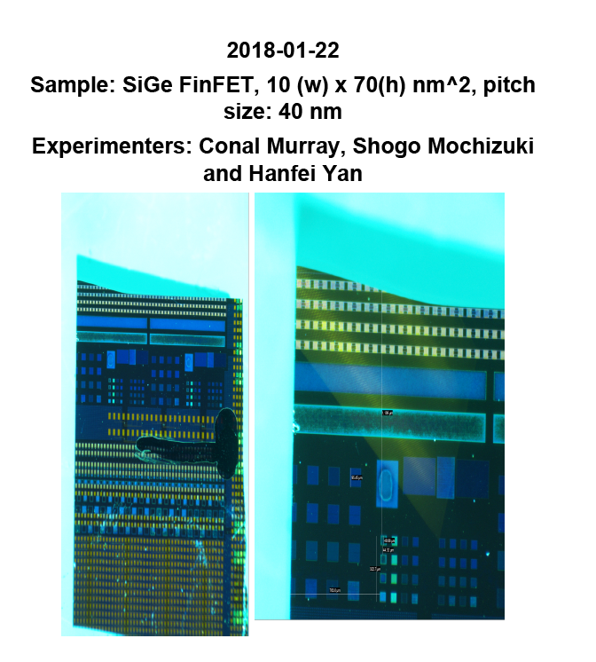

* To change the information shown on the title page, you need to run **setup_pdf()** again.
* To insert a figure, a note and a picture. The figure to be saved has to be the current active one. It is either the last created figure or the one you clicked. The command is,

**insertFig(note = ‘some note’, title = ‘some title’)**

By default the title will be the last scan command, so be sure it is what you want to add. The footnote and the title can’t be more than 10 words long.

* If you want to save a long text into the pdf, then you need to use the following command,

**insertNote()**

* It will prompt you to enter the content. You can also add an existing picture into the pdf. The syntax is very similar,

**insertPic(picFile =‘picture file to load’, note = ‘’, title =‘’)**

Note: In this case, there is no default title setting.

* Note: Each page of the pdf, except the title page, is formatted into a 3x2 array of blocks, and objects fill these blocks in sequence in memory. ***Only when the page in memory is full, a new page will be appended into the designated pdf file on the disk.***
* If you want to save a partial page, or before you exit the current session of the scan engine, to ensure everything is saved the following command should be used,

**save_page()**

* If you did make some mistake and want to undo an inserted object, you can use,

**undo_pdf()**

What it does is to roll back an internal counter and overwrite the block stored in memory. However, if a page has been saved into the disk, you can’t undo the saving. ***Commands used here never overwrite an existing pdf file on the disk; it only append new pages to it.*** A content page will look like,

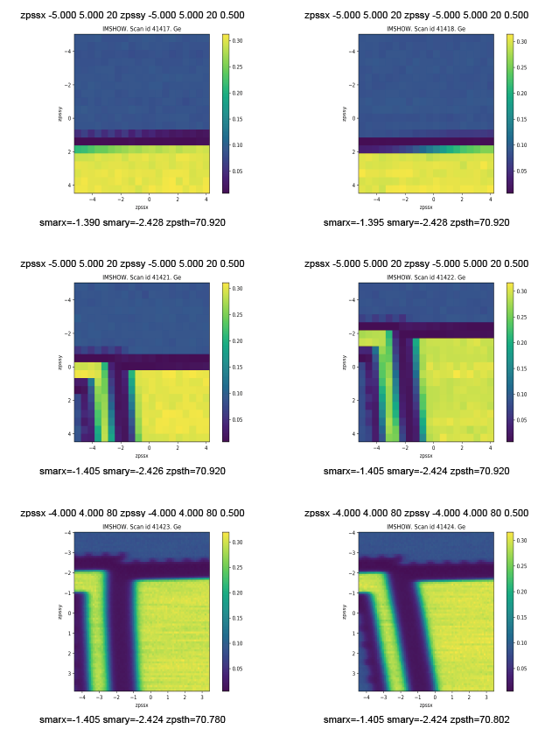

# Data Analysis

## Fetch data via dataBroker

* If one would like to fetch data in the scan engine, this can be done through dataBroker. First the header information of the interested scan with scan number sid needs to be retrieved,

**hdr = db[sid]**

* The header contains all scan-related information, try to type hdr[‘start’] and you will see a lot of information. To fetch the scalar data, one can use the following command,

**df = hdr.table()**

* If the name of the defined point detector is known, for example, ‘sclr1_ch4’, simply type,

**df[‘sclr1_ch4’]**

* all data will be shown on the screen. If you are not sure about the names, type,

**hdr.fields()**

* it will show all the field names defined. If 2D images are interested, for example the merlin detector with the name ‘merlin1’ defined in the database, they can be retrieved using,

**imgs = list(hdr.data(‘merlin1’)**

* In the databse, there are also baseline devices whose values are saved before and after the scan. For example, if we want to see the position of a coarse motor smarx for a particular scan, type,

**bl = hdr.table(’baseline’)**

**bl[‘smarx’]**

For whom want to know more, help documents can be found at http://nsls-ii.github.io/.

## Create your own workspace directory

Some software used at HXN, such as pyXRF, requires a workspace directory to store parameter files and processed data. For a better organization of the data, the creation of the workspace directory has to follow the following rules. A data directory is created for each beam cycle under /data/users/. For example, for the second cycle in 2017, the folder is /data/users/2017Q2 and is created by beamline staff. Each user has to create his own workspace directory under the corresponding beam cycle folder. Use PI’s last name and beam cycle for the folder name. For example, for a user experiment in the second cycle of 2017 with PI’s last name Yan, a folder /data/users/2017Q2/Yan_2017Q2 should be created and used to store all processed data. If they are stored elsewhere, they may be moved or even deleted without notice. Under this directory, it’s up to the user how to organize their data.

## pyXRF

pyXRF is a python-based software that does fluorescence spectrum fitting for quantitative elemental distribution analysis.

#### Prepare data

Before one can start to use pyXRF, data has to be fetched from dataBroker and packed into a special hdf5 format. In order to do so, ones goes to his workspace directory (refer to 4.2), and then type the following one-line command to go to ipython environment,

**run-pyxrftools**

If only scan with scan number sid is prepared, type,

**make_hdf(sid, fname=‘scan_sid.h5’)**

Note: the first argument of function ”make_hdf” is the scan # (i.e., 1000), the second is the hdf filename to be saved. It may take several minutes to load 200 by 200 dataset. When loading process is done, you will see ‘scan_1000.h5’ is created in your workspace directory. Use pyxrf to load that data and work on it. Also note that data can’t be created if data file already exists. You need to remove the old file first. If one wants to prepare multiple scans, type,

**make_hdf(1000, 1100)**

Note: the first argument is the starting run #, the second argument is the ending run #. This function will automatically transform all the fluorescence data within the run number range. If you want to define a prefix name, you can do make_hdf(1000, 1100, prefix=’abc_’). The default prefix name is ‘scan2D_’. Note that data can’t be created if data file already exists. You need to remove the old file first.

### Run pyXRF

At any terminal, type the following command to launch pyxrf,

**run-pyxrf**

The PyXRF GUI is shown in figure below. Detailed manual can be found in the following website: <https://github.com/NSLS-II/PyXRF>. In case if anything runs wrong on the GUI, close the terminal, and repeat the whole process to load pyxrf again. Make sure you input your workspace directory created before into “Working directory” field.

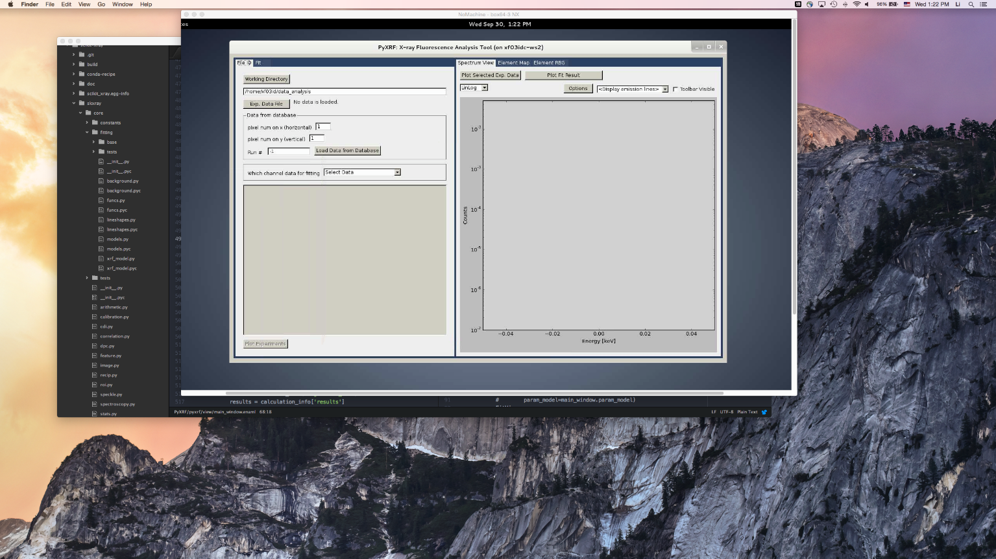

### Batch processing

For the same type of sample, the fitting parameters are the same for all the scans so one can batch-process the subsequent scans after figuring out the first good one. Go to your workspace directory, then type the following one-line command to go to ipython environment,

**run-pyxrftools**

In ipython, type,

**pyxrf_batch(1000,end_id=1100,param_file_name=’abc.json’,save_txt=True, save_tiff=False, ic_name='sclr1_ch4')**

Note: The first argument is starting run# (e.g. 1000), and second is ending run #, which can be set as end_id=None if you only have one data. This function will search within the current folder for all the h5 files whose names are within the defined range (start id, end id), and then perform automatic fitting. User also needs to define which json file to use, as given by param_file_name. User can set save_txt=True, save_tiff=True if they want to output both formats. ic_name means the ion chamber value to normalize data. Note: h5 files need to be created first in order to do automatic fitting. Also note: Normalization is performed as normed_data = data1/data2 * mean(data2).

## PyDPC

PyDPC is a python-based software that analyzes the farfield diffraction image from the nanobeam for differential-phase contrast and quantitative phase images. For those who are interested in its working principles, see the paper Sci. Reps. 3, 1307(2013).

#### Launch the program

At any terminal, type,

**run-dpc**

Or alternatively, go to /data/DPC/, and type,

Source activate analysis

This sets the right environment for PyDPC to work. Then type,

Python dpc_gui.py

#### Load data

A GUI will pop up after the program is launched successfully. To load the data from the metadatastore, 1-check the “Read from metadatastore” box, 2-input scan number and 3-click “Load” button. Wait until Range shows up (see below figure).

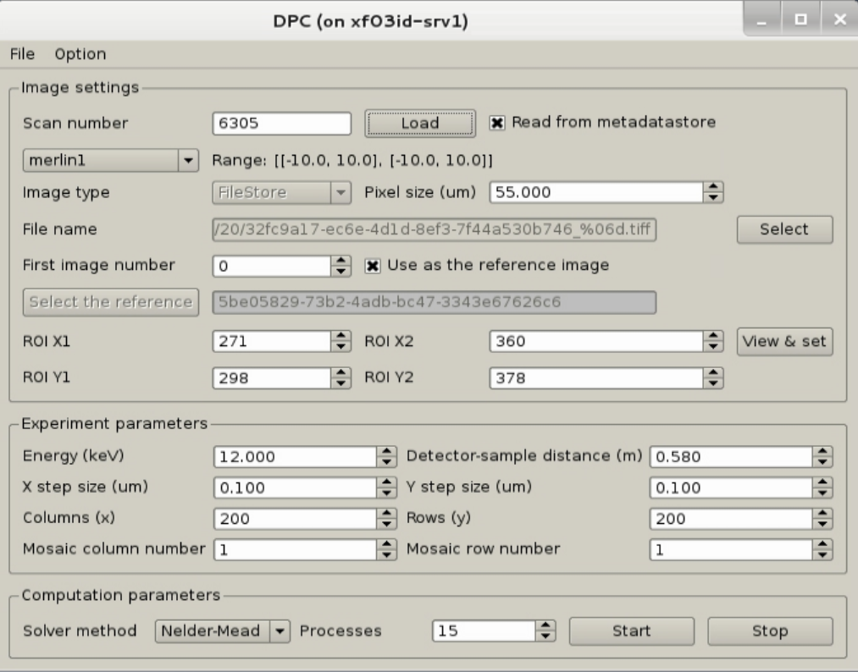

1

2

3

Wait for the scan range to be updated

Default setting. No need to change in most cases.

If one wants to load data from an existing directory that contains the image files (it supports tif, hdf5 and ASCII format), uncheck “read from metadatabase”, select the right type of file format, and then click “select” to choose the folder. Note: for hdf5 file it assumes all images data are stored in a single file, while for other types files with sequential numbers are expected. For the latter, it is important to input the correct starting number in “First image number”.

#### Select ROI on the image

If it is the first time to run the program, proper image ROI needs to be set. Click “View and set” button. Another window will pop up. Sometimes it takes tens seconds for it to load. Be patient.

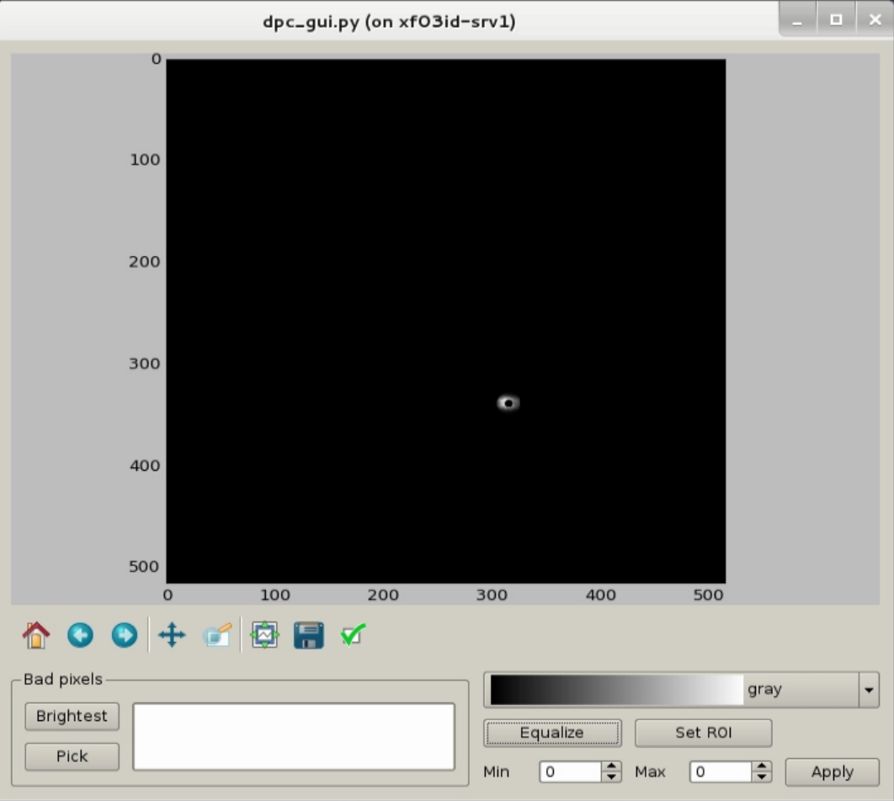

Right click to add/remove bad pixels to be masked

If there are bad pixels (hot pixels with extraordinary high intensity) in the pattern, one can mask them out. The bottom left two buttons are design for this purpose. “Brightest” automatically pick pixels with highest intensity and “Pick” allows manually select bad pixels. The white field will display current list of bad pixels, and one can add/remove them by right click. To select the ROI, click “Set ROI” button and draw a box around the far-field pattern from the focusing optic. A new window will pop up (see below figure).

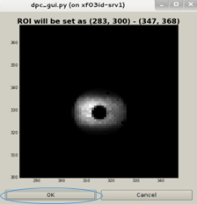

If it looks ok, click “OK” button to set ROI region. You only need to set ROI once if the detector position is not moved.

#### Process image data

Go back to the main window and make sure energy and detector-to-sample distance are input correctly. Other experimental parameters are updated automatically if the data loaded from the metadatabase. Otherwise make sure they are correct. Mosaic column and row numbers are always 1. They are used for complicated mosaic scans and currently not supported. The solver method in most cases doesn’t need to be changed, so leave the default one. One can also select multi-processors to speed up the processing. If load data from metadatabase, it is not recommended to use more than 5 processors due to some unknown file I/O issue. It may cause the program to crash. Finally, click “start” button to start the image data processing. A new window will pop up to show the updated results. Sometimes it may take a few minutes to finish, depending on the size of the data.

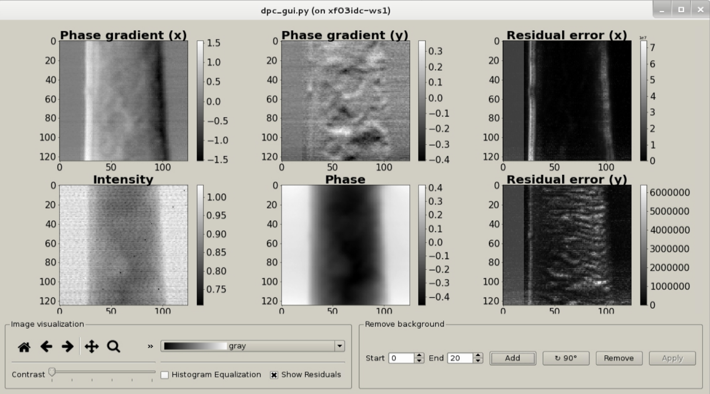

Sometime one may see either a graduate change or a stripe-like background due to beam motion. To remove them, input the start and end column number within which it is truly background (no sample) as a reference point. Click “Add” button and then a stripe will show up on “Phase gradient” image. Sometime one needs to click “rotate 90” button to orient the stripe correctly. Click “Remove” to remove background, which is the average value within the selected stripe. If the result is satisfied, click “Apply” to make the change permanently. Otherwise click “Add” again to go back to original images.

#### Save results

Results can be saved into stacked tiff, png and ASCII files. Go to the main GUI window and click “file” tab on top left corner. Choose the preferred data format to export data. It is recommended to use tiff. It is also recommended to save all the DPC images under the same workspace directory created for the current experiment.

#### Common issues

For DPC to work correctly, the farfield image orientation should be aligned with scan axes. However, this is often not guaranteed or even known if it is not recorded during the experiment. What we do know is that a sample should introduce a phase retard as to the background before its refractive index is smaller than one. If the reconstructed phase image doesn’t look correct, most likely it has an orientation problem. This can be easily corrected by swap x and y axes, or change the sign of them. Go to the main GUI and click the “option” tap. You will find a lot of options. Experiment it with different options until the image looks correct. Below are two examples showing how the image would look like if the orientation is incorrect.

X and y axes are swapped. x axis is reversed

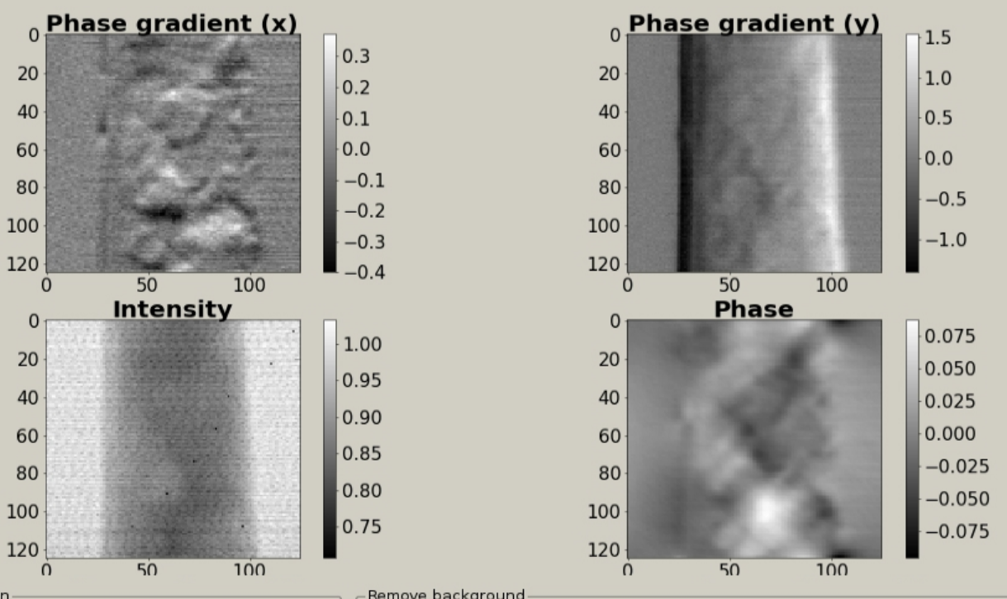 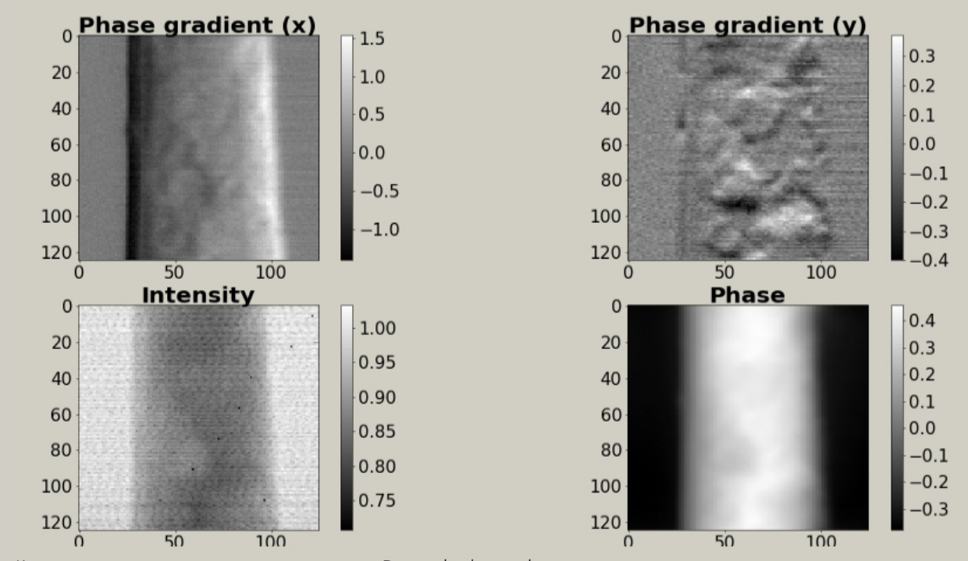

There are also cases where the sample is extended beyond the scanned area. Because of the nature of FFT, the image may “fold in” on the opposite side, which result in artificial object that is not real. This can be mitigated by choose “padding the image” in “option”. It does not affect the gradient maps.

No padding Padding

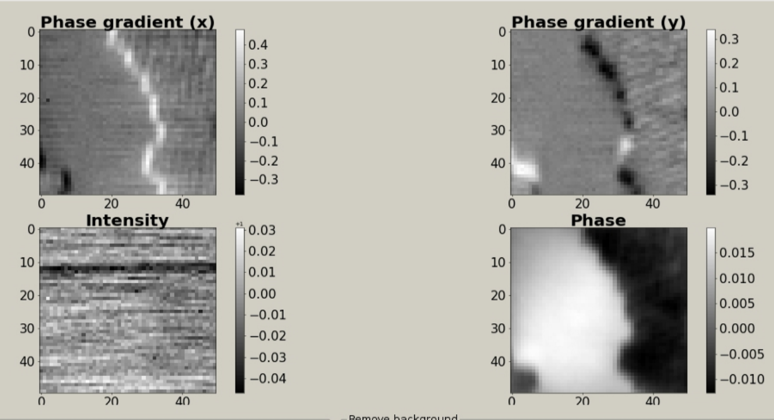  
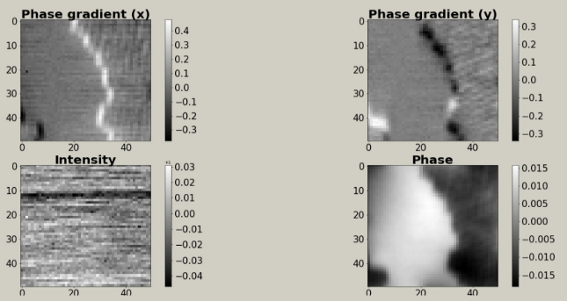

#### Batch processing

PyDPC supports batch processing. This can be done either from a script file or from the GUI. For simplicity, here we only discuss the GUI. Click file->launch DPC batch GUI will bring up the interface, and it will look like,

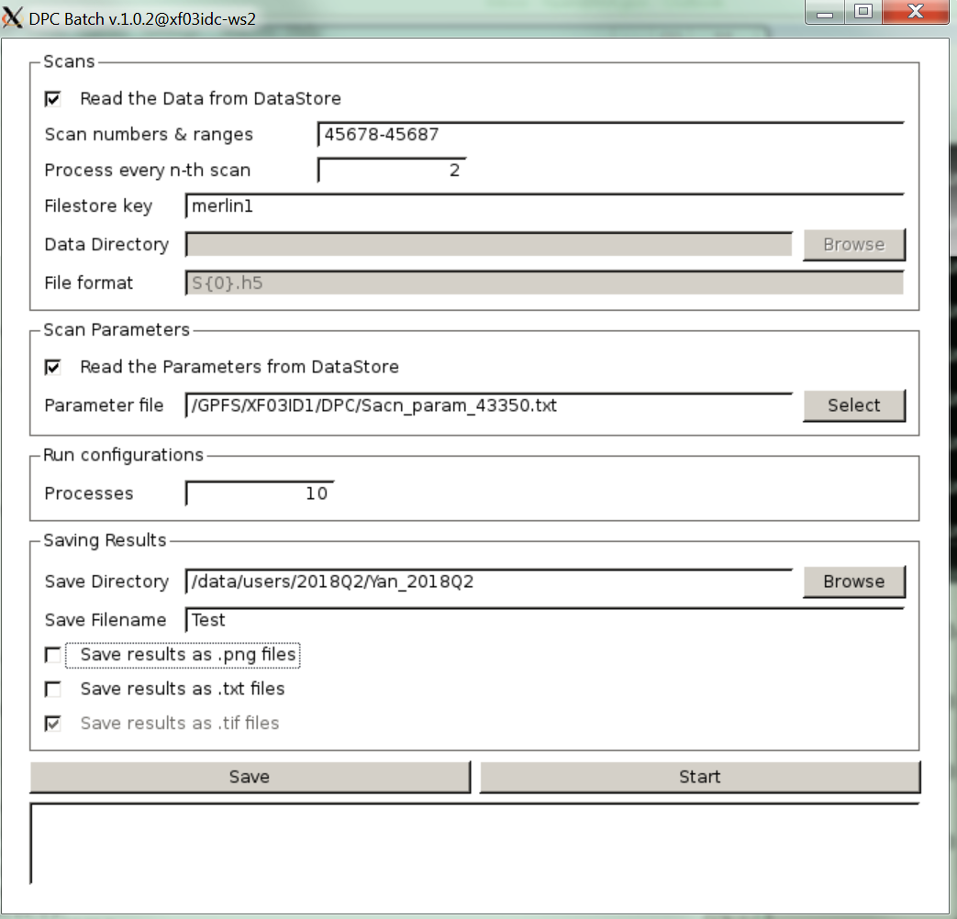

The GUI is self-explained and easy to understand. When read data directly from the database, one should check the “Read the data from DataStore” box and specify the range of scan numbers. In addition, one needs to specify the detector name and processing intervals. The latter is useful when there is alignment scan which does not require processing. One can also load data from a h5 files saved on a local disk, and specify the naming rule.

To process the data, a parameter file is always needed. This parameter file can be generated from the main GUI when all the parameters are checked for correct results. Some parameters can be read from the databroker and updated for each scan, if the box next to it is checked. To speedup the processing, multiple processes should be selected. All the results will be saved into the directory selected, with a prefix name shown in the “save filename” field. In default, a stacked tiff file is saved, but one can choose png or txt format alternatively.

Lastly, click “save” and then “Start” for batch processing.

## 5.5 Matlab

On workstation 2 (xf03idc-ws2), we have matlab installed. Simply type “matlab” to launch it.

## 5.6 Ptychography

We have in-house developed ptychography software that works in both transmission and Bragg diffraction geometries and runs on multiple GPUs for fast reconstruction. It is still in premature state, so discuss with beamline scientists for details.

# Diving board

HXN use a commercial Si sample holder with fidicial markers. To order, go to this link<http://www.norcada.com/products/xray-tomo-devices/>. Please use part number NCT4155P-III-Cr or NCT4155P-III-Pt. The difference is the material used for fiducial marker, which is labeled last in the part number (either Cr or Pt). Pt is used for operation energy above 11.56 keV. For any application that will run below this energy, Cr should be selected. Also note the lead time is long, 3 weeks after the order is placed. Below are the schematic drawing of the chip and the design of the fiducial pattern. All the lines are 5 um wide.

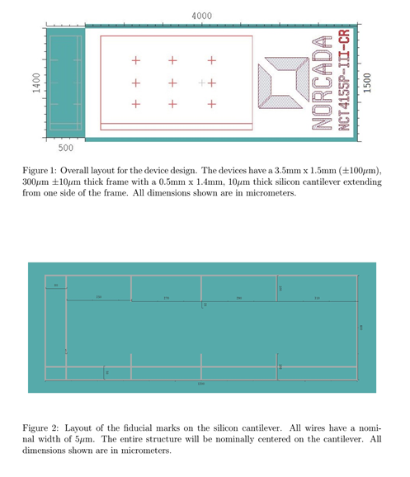

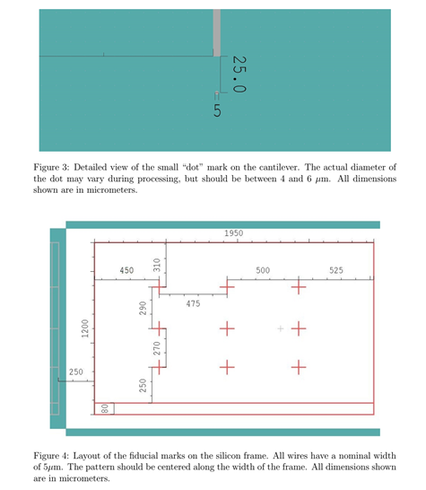

The sample should be mounted on the side with fiducial markers, and preferentially on the thin membrane that is sticking out. The membrane is easy to break so care should be taken when touching it. Sample mounted on the bottom thick part can still be imaged, if transmission imaging is not needed.

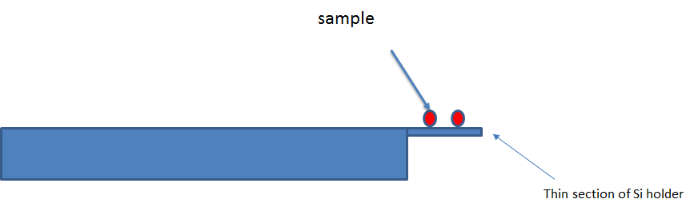

# Sample Exchange

During the experiment the sample chamber is in 250 mm Hg He atmosphere. Inserting or changing sample in microscope require venting the chamber and evacuating it after the exchange. The following steps should be followed. All the vacuum controls are done using a touch screen located behind the beamline. **The whole procedure can take about 1-2 hours.**

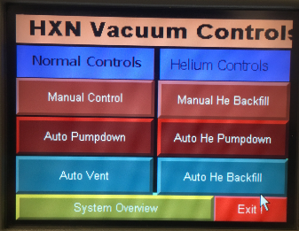

Home display

## Venting the chamber

* If in vacuum/He, vent the chamber with air.

*Home🡪Manual Control🡪Vent control🡪 Slow Open*

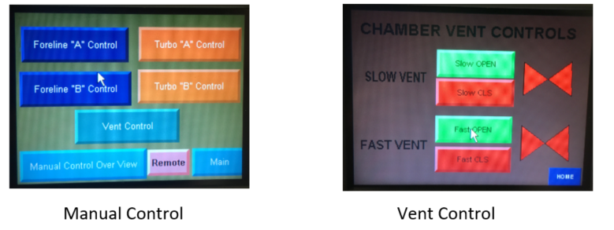

* After the pressure reached below 400 mm Hg press the fast open
* Now the chamber should be ready for sample mounting

## Evacuating the chamber

Start evacuating the chamber once the chamber door is tightened.

* Close the venting valves
  + *Home🡪Manual Control🡪Vent control🡪 Fast CLS and slow CLS*
* Start pumping; we have two pumps, labeled A &B.
  + *Home🡪Manual Control🡪Foreline “A”Control🡪 pump on🡪 slow open*
  + *Home🡪Manual Control🡪Foreline “B”Control🡪 pump on🡪 slow open*

After the pressure rech below 400 mm Hg open the ‘fast’ valves

* *Home🡪Manual Control🡪Foreline “A”Control🡪 pump on🡪 fast open*
  + *Home🡪Manual Control🡪Foreline “B”Control🡪 pump on🡪 fast open*
  + After the pressure reach below 1 mm Hg, we can fill He.

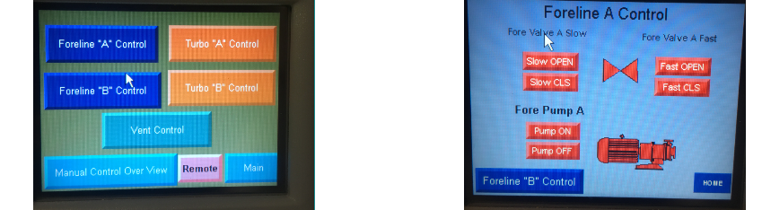

## Auto He back Fill

* + Close the valves and turn off the pumps
    - *Home🡪Manual Control🡪Foreline “A”Control🡪 fast close🡪slow CLS🡪pump OFF*
    - *Home🡪Manual Control🡪Foreline “B”Control🡪 fast close🡪slow CLS🡪pump OFF*
  + Turn on the He gas cylinder, they are near the beamline control area

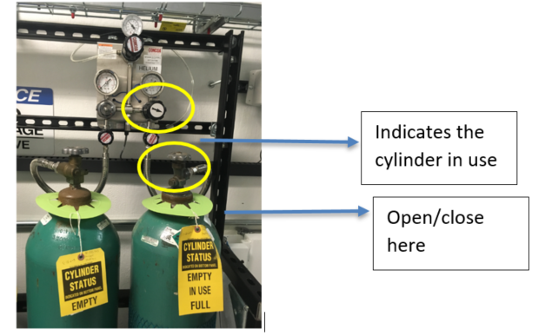

* + On the screen start the Auto He back fill,
    - *Home 🡪Auto He backfill🡪Start*

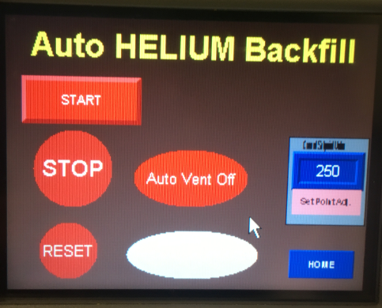

* + Once the pressure reached 250 mm Hg, just turn off the He cylinder. Nothing to do on the screen!